**Title:**

XOR LED Circuit (using NAND)

**Date:**

1/NOV/2018

**Aim:**

The aim of the experiment is to design and build a circuit that implements a quad NAND 7400 gate (four NAND gates in series) to create a logic gate that resembles an XOR gate.

**Analysis:**

I expected to get a truth table of a XOR gate, (Shown below).

|  |  |  |
| --- | --- | --- |
| **Input** |  | **Output** |
| **A** | **B** | **out** |
| 0 | 0 | 0 |
| 0 | 1 | 1 |
| 1 | 0 | 1 |
| 1 | 1 | 0 |

We were able to use DeMorgan’s theorem to establish an equation using only four NAND gates that would resemble the inputs and outputs of an XOR gate.

***F = A’B + AB’***

***By Boolean algebra…***

***F = ((A.(A.B)’)’.(B.(A.B)’)’)’***

**XOR GATE:**

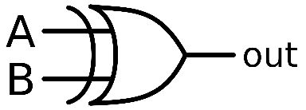

**Logic Diagram:**

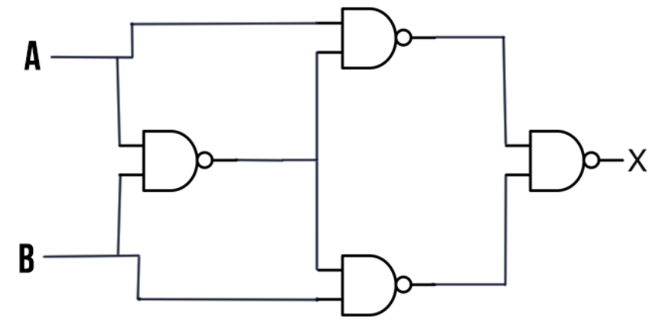

The logic behind the XOR gate is that if both inputs are either on or off, then the output would be off. Otherwise, the output would be on.

**Results:**

From our lab session we got the following results which matched that of the XOR gate truth table which told us that our results were correct.

|  |  |  |
| --- | --- | --- |
| **Input** |  | **Output** |
| **A** | **B** | **out** |
| 0 | 0 | 0 |
| 0 | 1 | 1 |
| 1 | 0 | 1 |
| 1 | 1 | 0 |

**Conclusion:**

In conclusion, the truth table from our analysis of the circuit diagram matched that of our results. The XOR gate allowed current to pass using 4 NAND gates as shown in the logic diagram. The showed that a XOR gate is just 4 NAND gates, arranged as the logic diagram, would create a XOR gate.